ISSUES : FIGURE SET
Thermal ecology and the fate of lizards on a warming planet

Tiffany M. Doan

Division of Natural Sciences, New College of Florida
tiffperu@yahoo.com

THE ISSUE
As a result of global change, increased temperatures across the planet force species to acclimate or adapt to higher environmental temperatures or face population decline or extinction. Reptiles utilize a variety of strategies to control their body temperatures but are ectothermic, typically controlling their body temperatures behaviorally. This Figure Set guides students to examine field data about thermoregulatory strategies of an unusual group of lizards, allowing students to determine whether the lizards are thermoregulators or thermoconformers. Based on their interpretation of data, students make predictions about the fate of these species under climate warming scenarios. Then the Figure Set provides laboratory data about critical temperatures of these same species, allowing them to forecast the consequences of global warming for these species and consider the broader implications of such research.

ECOLOGICAL CONTENT
thermal ecology, physiological ecology, climate change, global warming

STUDENT-ACTIVE APPROACHES
experimental design, think-pair-share, drawing predicted results, guided class discussion, interpreting data and results

STUDENT ASSESSMENTS
constructing a graph, answering questions on a worksheet, sharing responses with the class, designing an experimental setup, interpretating a graph, and completing an essay in which they assess their conclusions by considering the limitations and implications of the evidence

OVERVIEW

WHAT IS THE ECOLOGICAL ISSUE?
Global climate change is a severe threat to biodiversity through impacts that include habitat destruction and modification, pollution, global warming, and many other issues (IPCC 2014, Vitt et al. 2011, 2013). Many of the consequences of global climate change have been known for decades but much of the attention has concentrated on polar habitats and species (Deutsch et al. 2008). Tropical species, especially those living at high elevations, have rarely been studied with respect to global warming. A phenomenon that has already been observed is dubbed the “escalator to extinction” as species that live at high elevations move upslope to avoid increasing temperatures. This upward movement of lower elevation species squeezes higher elevation species into smaller ranges and they eventually run out of habitat (Marris, 2007; Freeman et al., 2018).

In the Central Andes of Peru and Bolivia, a genus of small lizards known as Proctoporus lives in high elevation habitats ranging from 1000 to 4080 meters above sea level (Doan et al. 2021). Two Proctoporus species have been studied in detail, P. unsaacae and P. sucullucu in the Sacred Valley of the Incas in Peru (Doan et al. 2021). Both species spend their entire lives under rocks and do not bask in the open (Doan et al. 2021). They remain under the same or nearby rocks their entire lives, with most individuals traveling less than 15 meters during their lifetimes (Doan et al. 2021). They eat small insects, reproduce by laying two eggs under rocks, and do not display parental care (Doan 2008, Doan et al. 2021).

In order to survive, organisms maintain stable operating condition within their cells, a process known as homeostasis (Hillis et al. 2020). Organisms vary widely in which attributes they maintain physiologically, including ion concentrations, pH, temperature, water volume, and many others (Hillis et al. 2020). Mammals and birds are well known to physiologically regulate body temperature through endothermy. Many reptiles, amphibian, fishes, and invertebrates maintain stable temperatures behaviorally rather than physiologically (known as ectothermy) (Pough et al. 2016). “Cold-blooded” reptiles are famous for using external environmental conditions to regulate their body temperatures by, for instance, basking in the sun to increase body temperature to a preferred level and retreating from the sun to cool off (Pough et al. 2016; Huey and Kingsolver 2019). However, there are reptiles that do not regulate their body temperatures much if at all (Doan et al. 2022), thus they “conform” to the temperature of their immediate surroundings. Such thermoconforming reptile species have not been studied to the extent that thermoregulators have (Doan et al. 2022).

For reptiles, the predictions about how they will handle climate change are dire. Global temperature increases are expected to contribute to the local extinction of 39% of all lizard populations and up to 20% extinction of lizard species within the next century (Sinervo et al. 2010). Doan et al. (2022) hypothesized that thermoregulating reptiles would fare better with temperature increases than thermoconforming reptiles because thermoregulators are better able to maintain their body temperatures than thermoconformers. One method that scientists use to test the extremes of temperatures that animals are able to tolerate is to calculate an animal’s critical thermal maximum (CT_{max}) and critical thermal minimum (CT_{min}) (Taylor et al. 2021). Such calculations can allow researchers to predict the fate of animals under a variety of climate change scenarios (Taylor et al. 2021).

LEARNING GOALS
In this teaching issue, students are challenged to consider their preconceived notions about reptile thermoregulation. In this activity, they draw and interpret graphs to determine that two Proctoporus species are thermoconformers. Students consider the differences in how thermoconforming and thermoregulating species may be affected by global climate change. They devise methods to determine critical thermal maxima and then compare their methods to a simple methodology from a published source. They interpret a graph with the published CT_{max} results for the two species and consider the implications of those data for the fate of the two species resulting from temperature increases due to climate change. They draw connections between physiological ecology and climate change.

FIGURE SET TABLE

Figure Set and  Ecological Question | Student-active Approach | Cognitive Skill | Class Size/Time
Both ambient (a, b) and substrate (c, d) temperatures were strongly correlated with cloacal body temperatures of Proctoporus unsaacae (a, c) and P. sucullucu, (b, d) in the Sacred Valley of the Incas, Peru.  Doan et al. (2021) | Experimental design, think-pair-share, drawing predicted results, guided class discussion, interpreting data and results | Know, comprehend, interpret, apply, analyze | Any/Moderate
Box-and-whisker plot of CT_{max} in ˚C for Proctoporus unsaacae and P. sucullucu in the Sacred Valley of the Incas, Cusco, Peru.  Doan et al. (2022) | Experimental design, guided class discussion, interpreting data and results | Know, comprehend, interpret, apply, analyze, evaluate | Any/Moderate

- Purpose: To interpret graphical results, link figures to concepts, understand the implications of global processes, and apply general knowledge to the physiological ecology of particular species
- Teaching Approach: Experimental design, think-pair-share, drawing predicted results, guided class discussion, interpreting data and results
- Cognitive Skills: knowledge, comprehension, interpretation, application, analysis, evaluation
- Student Assessment: class participation, short answer, written methodology, graph creation, essay on conclusions, limitations, and implications

FIGURE SET BACKGROUND

This figure set is intended for undergraduate students who have a background knowledge about temperature regulation. It may be used in a general biology class that covers homeostasis and how temperature is involved, a general biology class that covers physiological ecology, an ecology class, or a zoology class. For any of those types of classes, students are asked to combine information they have learned about physiology and ecology and to apply that knowledge to the threat of climate change. The two figures are taken from two papers about the biology of obscure high elevation South American lizards of which the students most likely have no knowledge. The first paper presents some basic ecology of two species for which none was previously known (Doan et al. 2021); the first figure for this exercise comes from that paper. Students learn how to use evidence to determine if ectothermic species are thermoregulators or thermoconformers. The second paper had the specific purpose of determining the potential consequences of global warming on the same two lizard species (Doan et al. 2022). This paper introduces the concept of critical thermal maxima (CT_{max}) and tests the CT_{max} of the two species. Contrary to the authors (and the students’) initial expectations, the second figure demonstrates that the two thermoconforming lizard species are quite robust to high temperatures and will likely not be negatively affected by the higher temperatures associated with global warming.

FIGURES

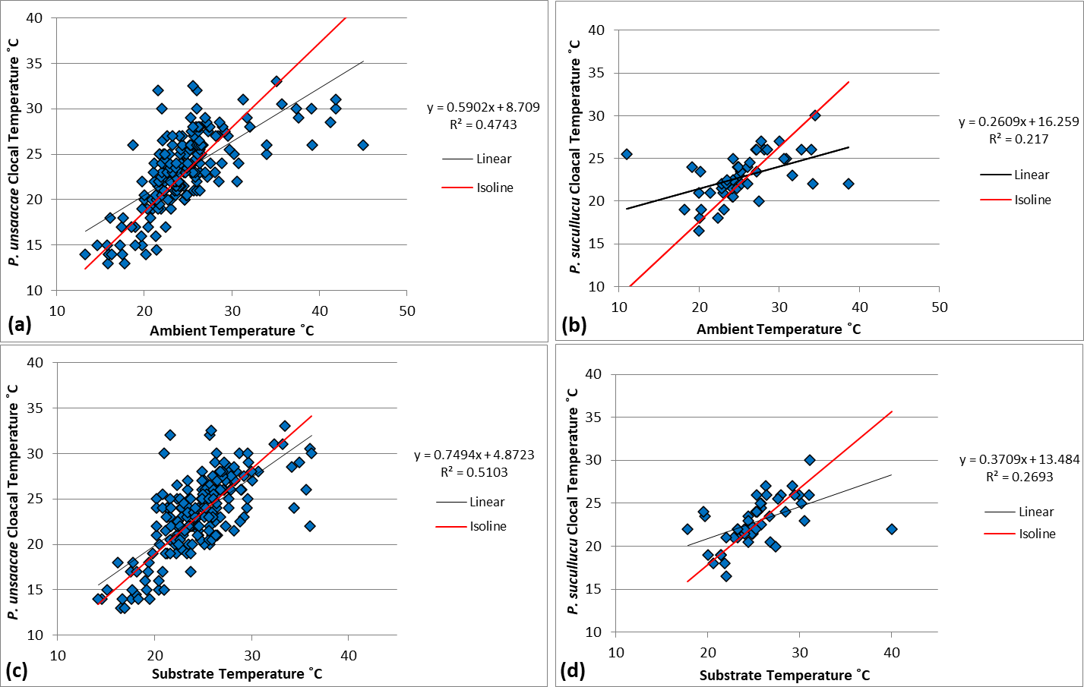

Figure 1. Both ambient (a, b) and substrate (c, d) temperatures were strongly correlated with cloacal body temperatures of Proctoporus unsaacae (a, c) and P. sucullucu (b, d) in the Sacred Valley of the Incas, Peru. Figure from Doan, T. M., S. A. Sheffer, N. R. Warmington, and E. E. Evans. 2021. Population biology of the unusual thermoconforming lizards of the Andes Mountains of Peru (Squamata: Gymnophthalmidae). Austral Ecology 46:1039–1051.

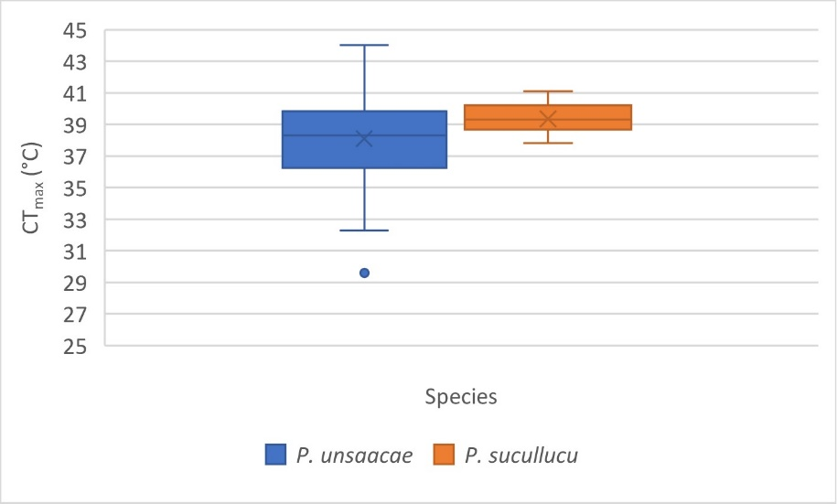

Figure 2. Box-and-whisker plot of CT_{max} in °C for Proctoporus unsaacae and P. sucullucu in the Sacred Valley of the Incas, Cusco, Peru. Figure from Doan, T. M., S. Markham, A. Gregory, A. Floyd, C. O. Broadwater, M. J. Goldberg, and B. Calder. 2022. Hot lizards: testing the tolerance to climate warming of thermoconformers in the Andes (Squamata: Gymnophthalmidae). Ichthyology & Herpetology 110:87-95.

STUDENT INSTRUCTIONS

OVERVIEW

What Is the Ecological Issue?
Global climate change is a severe threat to biodiversity through impacts that include habitat destruction and modification, pollution, global warming, and many other issues (IPCC 2014, Vitt et al. 2011, 2013). Many of the consequences of global climate change have been known for decades but much of the attention has concentrated on polar habitats and species (Deutsch et al. 2008). Tropical species, especially those living at high elevations, have rarely been studied with respect to global warming. A phenomenon that has already been observed is dubbed the “escalator to extinction” as species that live at high elevations move upslope to avoid increasing temperatures. This upward movement of lower elevation species squeezes higher elevation species into smaller ranges and they eventually run out of habitat (Marris, 2007; Freeman et al., 2018).

In the Central Andes of Peru and Bolivia, a genus of small lizards known as Proctoporus lives in high elevation habitats ranging from 1000 to 4080 meters above sea level (Doan et al. 2021). Two Proctoporus species have been studied in detail, P. unsaacae and P. sucullucu in the Sacred Valley of the Incas in Peru (Doan et al. 2021). Both species spend their entire lives under rocks and do not bask in the open (Doan et al. 2021). They remain under the same or nearby rocks their entire lives, with most individuals traveling less than 15 meters during their lifetimes (Doan et al. 2021). They eat small insects, reproduce by laying two eggs under rocks, and do not display parental care (Doan 2008, Doan et al. 2021).

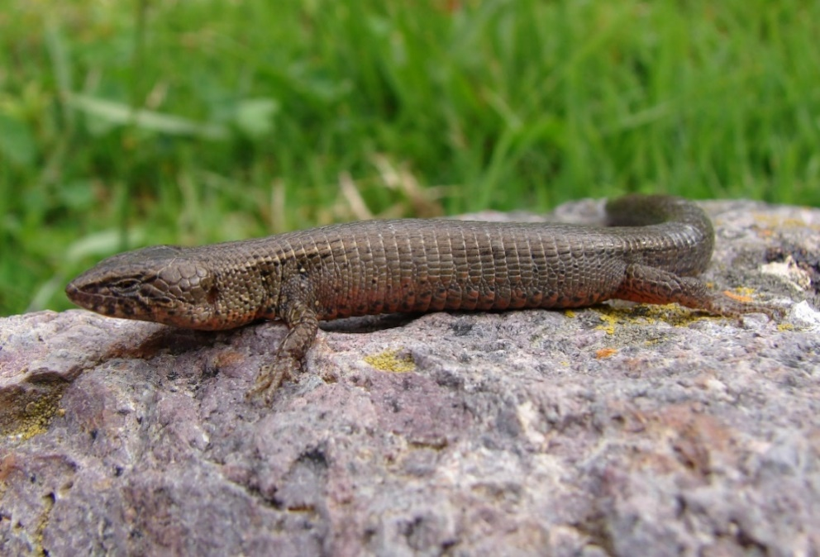
Proctoporus sucullucu in Ollantaytambo, Peru.

In order to survive, organisms maintain stable operating condition within their cells, a process known as homeostasis (Hillis et al. 2020). Organisms vary widely in which attributes they maintain physiologically, including ion concentrations, pH, temperature, water volume, and many others (Hillis et al. 2020). Mammals and birds are well known to physiologically regulate body temperature through endothermy. Many reptiles, amphibian, fishes, and invertebrates maintain stable temperatures behaviorally rather than physiologically (known as ectothermy) (Pough et al. 2016; Huey and Kingsolver 2019). “Cold-blooded” reptiles are famous for using external environmental conditions to regulate their body temperatures by, for instance, basking in the sun to increase body temperature to a preferred level and retreating from the sun to cool off (Pough et al. 2016). However, there are reptiles that do not regulate their body temperatures much if at all (Doan et al. 2022), thus they “conform” to the temperature of their immediate surroundings. Such thermoconforming reptile species have not been studied to the extent that thermoregulators have (Doan et al. 2022).

For reptiles, the predictions about how they will handle climate change are dire. Global temperature increases are expected to contribute to the local extinction of 39% of all lizard populations and up to 20% extinction of lizard species within the next century (Sinervo et al. 2010). Doan et al. (2022) hypothesized that thermoregulating reptiles would fare better with temperature increases than thermoconforming reptiles because thermoregulators are better able to maintain their body temperatures than thermoconformers. One method that scientists use to test the extremes of temperatures that animals are able to tolerate is to calculate an animal’s critical thermal maximum (CT_{max}) and critical thermal minimum (CT_{min}) (Taylor et al. 2021). Such calculations can allow researchers to predict the fate of animals under a variety of climate change scenarios (Taylor et al. 2021).

LITERATURE CITED
Deutsch, C. A., J. J. Tewksbury, R. B. Huey, K. S. Sheldon, C. K. Ghalambor, D. C. Haak, and P. R. Martin. 2008. Impacts of climate warming on terrestrial ectotherms across latitude. Proceedings of the National Academy of Sciences of the United States of America 105:6668–6672.
Doan, T. M. 2008. Dietary variation within the Andean lizard clade Proctoporus Squamata: Gymnophthalmidae). Journal of Herpetology 42:16–21.
Doan, T. M., S. A. Sheffer, N. R. Warmington, and E. E. Evans. 2021. Population biology of the unusual thermoconforming lizards of the Andes Mountains of Peru (Squamata: Gymnophthalmidae). Austral Ecology 46:1039–1051.
Doan, T. M., S. Markham, A. Gregory, A. Floyd, C. O. Broadwater, M. J. Goldberg, and B. Calder. 2022. Hot lizards: testing the tolerance to climate warming of thermoconformers in the Andes (Squamata: Gymnophthalmidae). Ichthyology & Herpetology 110:87-95.
Freeman, B. G., M. N. Scholer, V. Ruiz-Gutierrez, and J. W. Fitzpatrick. 2018. Climate change causes upslope shifts and mountaintop extirpations in a tropical bird community. Proceedings of the National Academy of Sciences of the United States of America 115:11982–11987.
Huey, R. B., and J. G. Kingsolver. 2019. Climate warming, resource availability, and the metabolic meltdown of ectotherms. The American Naturalist 194:E140–E150.
Hillis, D. M., H. C. Heller, S. D. Hacker, D. W. Hall, M. J. Laskowski, and D. E. Sadava. 2020. Life: The Science of Biology, 12th Edition. Sinauer Associates, USA.
IPCC (Intergovernmental Panel on Climate Change). 2014. Climate Change 2014: Impacts, Adaptation, and Vulnerability. Part A. Global and Sectoral Aspects. Cambridge University Press, Cambridge, U.K.
Marris, E. 2007. The escalator effect. Nature Climate Change 1:94–96.
Pough, F. H., R. M. Andrews, M. L. Crump, A. H. Savitzky, K. D. Wells, and M. C. Brandley. 2016. Herpetology, Fourth Edition. Sinauer Associates, USA.
Sinervo, B., F. Méndez-de-la-Cruz, D. B. Miles, B. Heulin, E. Bastiaans, M. Villagrán-Santa Cruz, R. Lara-Resendiz, N. Martínez-Mendez, M. L. Calderón-Espinosa, R. N. Meza-Lázaro, H. Gadsden, L. J. Avila, M. Morando, I. J. De la Riva . . . J. W. Sites, Jr. 2010. Erosion of lizard diversity by climate change and altered thermal niches. Science 328:894–899.
Taylor, E. N., L. M. Diele-Viegas, E. J. Gangloff, J. M. Hall, B. Halpern, M. D. Massey, D. Rodder, N. Rollinson, S. ¨ Spears, B. Sun, and R. S. Telemeco. 2021. The thermal ecology and physiology of reptiles and amphibians: a user’s guide. Journal of Experimental Zoology Part A: Ecological and Integrative Physiology 335:13–44.
Vitt, L. J., S. S. Sartorius, T. C. S. Avila-Pires, and M. Esposito M. C. 2001. Life at the river’s edge: ecology of Kentropyx altamazonica in Brazilian Amazonia. Canadian Journal of Zoology 79:1855–1865.
Vitt, L. J., T. C. S. Avila-Pires, P. A. Zani, S. S. Sartorius, and M. C. Esposito. 2003. Life above ground: ecology of Anolis fuscoauratus in the Amazon rain forest, and comparisons with its nearest relatives. Canadian Journal of Zoology 81:142–156.

Part 1

- Consider the potential consequences of climate change for the geographic range of a species. Discuss these with a neighbor.
- Go back to your previous answer, do you believe the consequences would be the same or different between endothermic and ectothermic animals? Why or why not? Discuss your ideas with a neighbor.
- How could you tell the difference between a thermoregulator and a thermoconformer?
- What kind of data would you need to determine which category a species falls into?
- If you had data on environmental temperature versus body temperature, draw a possible graph if the animal was a good thermoregulator.
- Add data for a thermoconformer to the graph.

Part 2

As explained in the Part 1, Proctoporus lizards live at high elevations in the Andes Mountains where they experience cold conditions year-round. Therefore, it is likely that they have evolved to live in cold temperatures.

Examine Figure 1 which has data from two Proctoporus species. Study the graph type and the axes. Cloacal temperature is a measure of body temperature. Ambient temperature is the temperature of the air, whereas substrate temperature is the temperature of the rock under which the lizard was found.

Figure 1.

- Do these species appear to be thermoregulators or thermoconformers? How do you know?
- How do these graphs relate to the graph you sketched in Part 1?
- What do the differences between the top graphs (a and b) and bottom graphs (c and d) tell you about this species and thermoregulation in general?

Write and submit a short paragraph that integrates the answers of the three questions above.

Part 3

The graphs from Part 2 have the following figure caption: Both ambient (a, b) and substrate (c, d) temperatures were strongly correlated with cloacal body temperatures of Proctoporus unsaacae (a, c) and P. sucullucu (b, d) in the Sacred Valley of the Incas, Peru. Figure from Doan, T. M., S. A. Sheffer, N. R. Warmington, and E. E. Evans. 2021. Population biology of the unusual thermoconforming lizards of the Andes Mountains of Peru (Squamata: Gymnophthalmidae). Austral Ecology 46:1039–1051.

Figure 1 demonstrates that both species of Proctoporus are thermoconformers. You can see that by their body temperatures being strongly correlated with substrate (rock) temperatures and also correlated with ambient (air) temperatures (in the article all P-values were ≤ 0.001). For animals that are thermoregulators, their body temperatures remain approximately the same throughout daylight hours, regardless of ambient or substrate temperature. Below is a graph of a thermoregulating lizard species, for comparison.

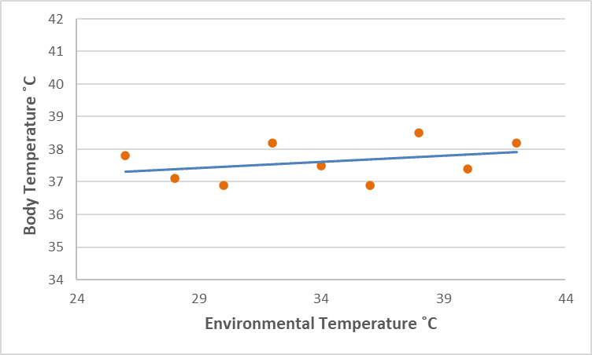
Environmental temperature versus body temperature of active Ameiva ameiva lizards from the Brazilian rainforest (G. Colli, pers. comm.).

- What do you think the differences in susceptibility to global warming would be between thermoregulators and thermoconformers? Discuss your ideas with a neighbor.
- Make a prediction about the fate of Proctoporus with the advance of global warming. Consider the high elevation habitat they inhabit. Discuss your ideas with a neighbor.
- Devise a method for testing CT_{max} of these lizards. Describe in paragraph, list, and/or diagram form.

Part 4

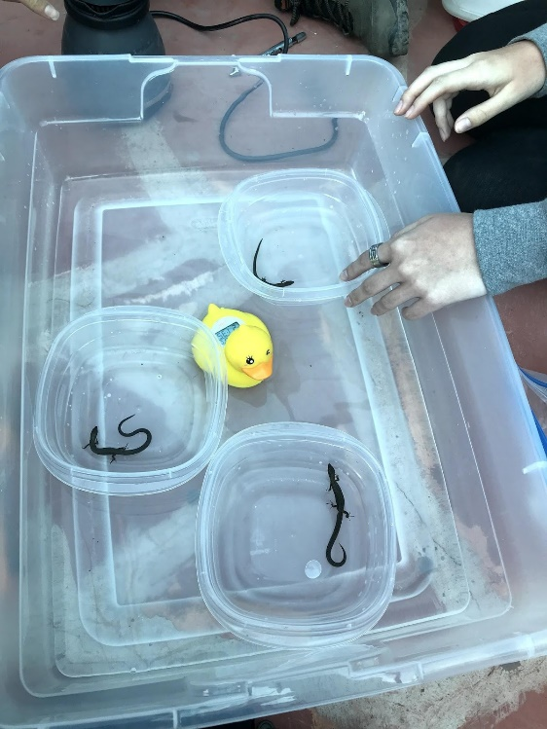
According to the Methods section of Doan et al. (2022), they collected lizard specimens from underneath rocks in their native habitats. Specimens were then transported back to the laboratory. After acclimating for 16–24 hours in the field laboratory, they tested each specimen to determine its CT_{max}. They used a large plastic tub filled to 1.5 cm of water starting at 22–23 °C. Each specimen was removed from its bag and placed into a small plastic container floating within the larger container. Before testing began, they ensured that the lizard’s body temperature equaled the water temperature, which took little time with these small-bodied species. They measured water temperature with a floating bath thermometer; ambient and specimen temperatures were measured with an infrared thermometer. Once acclimated, they recorded starting time and gradually added hot water (provided by an electric kettle) to the large container every 2 minutes to increase the temperature 0.5 °C, which took less than one minute. The test continued until the specimen demonstrated distress in the form of a muscular spasm, which was defined as an uncontrollable twitch or sudden flip of the body. When this occurred, they recorded the temperature of the water and time elapsed. They continued to raise the water temperature 0.5 °C every 2 minutes until the specimen demonstrated spasms continuously for three seconds or there were five individual occurrences of spasms for that specimen. That endpoint was recorded as CT_{max} and the specimen was removed and slowly restored to a non-critical temperature to ensure survival by placing their tray in a tub of warm water, making sure not to place any specimen in an environment more than 10 °C cooler than the temperature at which they concluded the test to prevent thermal shock. All specimens survived the procedure and were released back to their marked home rocks later in the day.

Figure 2. Box-and-whisker plot of CT_{max} in °C for Proctoporus unsaacae and P. sucullucu in the Sacred Valley of the Incas, Cusco, Peru. Figure from Doan, T. M., S. Markham, A. Gregory, A. Floyd, C. O. Broadwater, M. J. Goldberg, and B. Calder. 2022. Hot lizards: testing the tolerance to climate warming of thermoconformers in the Andes (Squamata: Gymnophthalmidae). Ichthyology & Herpetology 110:87-95.

When they were captured, Proctoporus unsaacae had field body temperatures of 18.1 ± 2.9 °C (range = 14.4–29.0 °C), whereas P. sucullucu individuals had mean field body temperatures of 16.8 ± 2.3 °C (range = 13.9–21.1 °C). The mean CT_{max} calculated for Proctoporus unsaacae was 38.17 ± 2.8 °C (range = 29.6–44.0 °C; n = 39). Proctoporus sucullucu had a higher mean CT_{max} of 39.35 °C ± 0.9 (range = 37.8–41.1 °C; n = 22). All means ± standard deviation.

- Examine the graph and the data below the graph. Do these two species have a high or low CT_{max}?
- What can you forecast about how global warming will affect these lizard species?
- Write a short paragraph about your conclusions. Also include what additional data you might want to collect that would further support your conclusions.
- Write a second short paragraph about the broader implications and limitations of this research.

Answer Sheet

Part 1.
Draw your graph here:

Part 2.
Write a short paragraph that integrates the answers of the three questions.
- Do these species appear to be thermoregulators or thermoconformers? How do you know?
- What do the differences between the top graphs (a and b) and bottom graphs (c and d) tell you about this species and thermoregulation in general?
- How do these graphs relate to the graph you sketched in Part 1?

Part 3.
Devise a method for testing CT_{max} of these lizards. Describe in paragraph, list, and/or diagram form.

Part 4.
What can you forecast about how global warming will affect these lizard species? Write a short paragraph about your conclusions. Also include what additional data you might want to collect that would further support your conclusions.

Write a second short paragraph about the broader implications and limitations of this research.

NOTES TO FACULTY

The activity is appropriate for undergraduate students who have a background knowledge about temperature regulation. It may be used in a general biology class that covers homeostasis and how temperature is involved, a general biology class that covers physiological ecology, an ecology class, or a zoology class. For any of those types of classes, students are asked to integrate information they have learned about physiology and ecology and to apply that knowledge to the threat of climate change. This activity incorporates aspects of the Four Dimensional Ecology Education (4DEE) framework, including the Core Ecological Concepts dimension of Organisms (abiotic and biotic features of the environment) and Biosphere (global climate change). This activity also uses the Ecology Practices dimension of Designing and Critiquing Investigations. It addresses the Human-Environment Interactions dimension of Human Accelerated Environmental Change (global climate change). Depending on the students’ backgrounds, they may need guidance on creating, reading, and interpreting scatterplots and box-and-whisker plots. It is useful to inform the students that the point of the activity is to see how animal physiology and ecology are connected to the larger issues of global change and threats to species and habitats.

The two figures are taken from two published papers that were coauthored with undergraduate students about the biology of obscure high elevation South American lizards of which the students most likely have no knowledge. The first paper, which presents basic ecology of two Proctoporus species (Doan et al. 2021), includes the first figure of this exercise from which students use evidence to determine if ectothermic species are thermoregulators or thermoconformers. The second paper focuses on the potential consequences of global climate change on the same two lizard species (Doan et al. 2022) and introduces the concept of critical thermal maxima (CT_{max}). Contrary to the authors initial expectations, the second figure demonstrates that both thermoconforming lizard species are quite robust to high temperatures and will likely not be directly negatively affected by the increased environmental temperatures associated with global climate change.

The module is divided into four parts, which should be done in order because they build upon each other. It is possible that faculty could adapt the module to their uses and cut out or expand various parts. Each part should be administered before the students see the following part. That is, students should complete Part 1 before they see the graphs from Part 2, which give away some of the answers from Part 1 and so on. Faculty could either hand out each part on paper along the way or simply project each part for viewing by the class.

The module may be implemented in a single 75–80-minute class period or may be broken up by part. During implementation in a general biology course, Part 1 averaged 21 minutes; Part 2 averaged 14.5 minutes; Part 3 averaged 12 minutes; Part 4 averaged 14 minutes. Although this activity was created to be administered in an in-person class, it could also easily be administered through a synchronous online class. It would not work very well, however, in an asynchronous class because subsequent parts give away answers of earlier parts.

The final pages of the student handouts packet have an answer sheet that could be handed out and collected for evaluation. Another option would be for the faculty member to create four assignments in their Learning Management System (LMS) and have the assignment for each part uploaded to the LMS as they go (either for an in-person or online class). For the drawings, students could take photographs with their phones and upload the photos for those parts. Part of the answer sheet is intended to be evaluated using the American Association of Colleges and Universities (AAC&U) Valid Assessment of Learning in Undergraduate Education (VALUE) Rubric for the Inquiry and Analysis learning outcome.

For Part 1, students read the introductory information and then discuss Questions 1 and 2 with neighbors in a Think-Pair-Share format. For Question 1, students could reference their knowledge and the material discussed in the introduction to determine that ranges of species might contract, shift northward, or move further up in elevation. For Question 2, students would most likely expect that thermoregulators would handle global warming better than thermoconformers because they have tighter control of their body temperatures. However, generating heat through metabolic processes also requires more energy resources. There is no correct or incorrect answer to this question. Questions 3 and 4 can be accomplished through a short class discussion. For Questions 3 and 4, students may have many ideas ranging from field observations to laboratory experiments. Body temperatures of a species over a variety of times and conditions would be necessary. For Questions 5 and 6, students sketch a graph on paper. The graph should be a scatterplot with environmental temperature (independent variable) on the X-axis and body temperature (dependent variable) on the Y-axis. An example graph appears below.

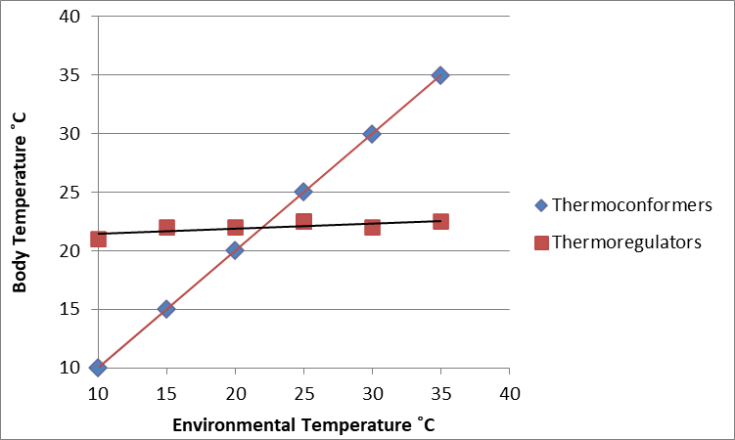

The graph created in Part 1 may be evaluated using the Graph Rubric (Angra and Gardner 2018) or another method that the instructor sees fit. Students who do not have much background in determining which types of graphs should be used with certain data types may need a lot of help with constructing a graph. Questions 5 and 6 could be used to teach about graph types, independent versus dependent variables, and required attributes of graphs such as labeling axes, etc.

For Part 2, show the students the graphs, answer any questions and then have the students write a short paragraph with the answers to the three questions. The paragraph of Part 2 may be evaluated with the Analysis criterion of the Inquiry and Analysis VALUE rubric. For Question 1, the lizards appear to be thermoconformers because there is a strong relationship between environmental temperature and lizard body temperature. For Question 2, have the students compare their graphs to the published graphs. A few students can volunteer to compare their graphs for the class. For Question 3, the data show that the lizard body temperature is more similar to rock (substrate) temperature than air (ambient) temperature. This demonstrates how the body temperature of ectothermic animals may depend on their microhabitat temperature more than overall environmental temperature.

For Part 3, allow students to examine the caption of the graphs from Part 2. Point out that three out of the four authors from the published paper were undergraduate students. Use Think-Pair-Share to discuss the first two questions. For Question 1, most students will assume that thermoregulators will be less harmed by global warming than thermoconformers, but there may be some students who believe the opposite. For Question 2, students most likely will determine that Proctoporus will suffer population decline or extinction with global warming because they are thermoconformers that do not move large distances and that live in high elevation habitats where upward migration would be very difficult. Next, inform the students that they are at the same level of knowledge as the faculty/student research team was in early 2019 before they began the subsequent project. Have students devise a testing method for CT_{max} of the lizards by drawing, listing, or writing in paragraph form. Have a few students share their methodologies with the class. The methodology the students create in Part 3, may be evaluated with the Design Process criterion of the Inquiry and Analysis VALUE rubric. One potential answer appears in Part 4 but there are many acceptable methodologies that could be used.

For Part 4, have students read the excerpt from the Methods section of the second paper that had six undergraduate coauthors. With more funding and a dedicated laboratory, the project team could have used expensive equipment to test the animals but they came up with a simpler, less expensive method that could be performed in a field lab. Have students examine the box-and-whisker plot and then discuss how the CT_{max} compares to their expectations. For reference, 38 ˚C is approximately 100 ˚F. This is an opportunity to teach students about simple box-and-whisker plots. Ask students to write two short paragraphs about conclusions and broader implications and limitations of the study. The Conclusions criterion of the Inquiry and Analysis VALUE rubric may be used to evaluate the first paragraph and the Limitations and Implications criterion of the Inquiry and Analysis VALUE rubric may be used to assess the second paragraph. With no context of the CT_{max} of other lizards, students cannot say for sure whether the CT_{max} is high or low but it should seem quite high to them, which in fact it is compared to other high elevation lizards. These lizards should not suffer direct effects of increased temperatures associated with global warming because their habitats will never approach the thermal maxima of these lizards. Proctoporus are able to function at a wide range of temperatures (as demonstrated in Figure 1), which means that slightly higher than average temperatures associated with climate warming most likely will not restrict activity. Unlike many other species around the world, these lizard species are unlikely to be driven to extinction due simply to warming associated with climate change. Additional studies would be needed to confirm that the species will not be negatively affected by increased temperatures. In order to be certain, studies of the fitness of these lizards would be needed. There could be sublethal effects of warmer temperatures that do not kill the lizards but may reduce reproductive success, causing lower fitness. It is conceivable that these high CT_{max} results may be expanded to other thermoconforming animal species but without research on more thermoconformers, we cannot be sure. Moreover, climate change does not only increase temperatures but can also change weather patterns, cause droughts, cause flooding, change phenologies of various species, etc., so it is important to recognize that, although increased environmental temperatures will not kill these lizards, other effects of climate change may still negatively affect them.

This module should allow students to use their knowledge and new evidence to synthesize aspects of physiology and ecology to apply to the existential threat posed by climate change. Students learn about graphing and use creative ideas to come up with an appropriate methodology to address important problems in the world today. This module shows them how relevant their biological knowledge can be to society and the environment.

RESOURCES

- Links to the studies used in this Figure Set:
Doan, T. M., S. A. Sheffer, N. R. Warmington, and E. E. Evans. 2021. Population biology of the unusual thermoconforming lizards of the Andes Mountains of Peru (Squamata: Gymnophthalmidae). Austral Ecology 46:1039–1051. https://onlinelibrary.wiley.com/doi/10.1111/aec.13036
Doan, T. M., S. Markham, A. Gregory, A. Floyd, C. O. Broadwater, M. J. Goldberg, and B. Calder. 2022. Hot lizards: testing the tolerance to climate warming of thermoconformers in the Andes (Squamata: Gymnophthalmidae). Ichthyology & Herpetology 110:87-95. https://bioone.org/journals/ichthyology-and-herpetology/volume-110/issue-1/h2021059/Hot-Lizards--Testing-the-Tolerance-to-Climate-Warming-of/10.1643/h2021059.full
- Intergovernmental Panel on Climate Change
https://www.conservation.org/stories/ipcc-reports-on-climate-change?gclid=CjwKCAjw0a-SBhBkEiwApljU0nbrFXfsBDfJMu-Y8DNuuZb6eeyTgvollGDcDX7A0YYWusfvA5baLxoCS_kQAvD_BwE
- The Reptile Database entries for both species with photographs
https://reptile-database.reptarium.cz/species?genus=Proctoporus&species=sucullucu
https://reptile-database.reptarium.cz/species?genus=Proctoporus&species=unsaacae
- Four Dimensional Ecology Education (4DEE) framework
https://www.esa.org/4dee/
- American Association of Colleges and Universities (AAC&U) VALUE Rubrics
https://www.aacu.org/initiatives/value-initiative/value-rubrics
- The Graph Rubric: Development of a Teaching, Learning, and Research Tool
https://www.lifescied.org/doi/10.1187/cbe.18-01-0007

LITERATURE CITED
Angra, A., and S. M. Gardner. 2018. The graph rubric: development of a teaching, learning, and research tool. CBE—Life Sciences Education 17:1–18.
Deutsch, C. A., J. J. Tewksbury, R. B. Huey, K. S. Sheldon, C. K. Ghalambor, D. C. Haak, and P. R. Martin. 2008. Impacts of climate warming on terrestrial ectotherms across latitude. Proceedings of the National Academy of Sciences of the United States of America 105:6668–6672.
Doan, T. M. 2008. Dietary variation within the Andean lizard clade Proctoporus (Squamata: Gymnophthalmidae). Journal of Herpetology 42:16–21.
Doan, T. M., S. A. Sheffer, N. R. Warmington, and E. E. Evans. 2021. Population biology of the unusual thermoconforming lizards of the Andes Mountains of Peru (Squamata: Gymnophthalmidae). Austral Ecology 46:1039–1051.
Doan, T. M., S. Markham, A. Gregory, A. Floyd, C. O. Broadwater, M. J. Goldberg, and B. Calder. 2022. Hot lizards: testing the tolerance to climate warming of thermoconformers in the Andes (Squamata: Gymnophthalmidae). Ichthyology & Herpetology 110:87-95.
Freeman, B. G., M. N. Scholer, V. Ruiz-Gutierrez, and J. W. Fitzpatrick. 2018. Climate change causes upslope shifts and mountaintop extirpations in a tropical bird community. Proceedings of the National Academy of Sciences of the United States of America 115:11982–11987.
Huey, R. B., and J. G. Kingsolver. 2019. Climate warming, resource availability, and the metabolic meltdown of ectotherms. The American Naturalist 194:E140–E150.
Hillis, D. M., H. C. Heller, S. D. Hacker, D. W. Hall, M. J. Laskowski, and D. E. Sadava. 2020. Life: The Science of Biology, 12th Edition. Sinauer Associates, USA.
IPCC (Intergovernmental Panel on Climate Change). 2014. Climate Change 2014: Impacts, Adaptation, and Vulnerability. Part A. Global and Sectoral Aspects. Cambridge University Press, Cambridge, U.K.
Marris, E. 2007. The escalator effect. Nature Climate Change 1:94–96.
Pough, F. H., R. M. Andrews, M. L. Crump, A. H. Savitzky, K. D. Wells, and M. C. Brandley. 2016. Herpetology, Fourth Edition. Sinauer Associates, USA.
Sinervo, B., F. Méndez-de-la-Cruz, D. B. Miles, B. Heulin, E. Bastiaans, M. Villagrán-Santa Cruz, R. Lara-Resendiz, N. Martínez-Mendez, M. L. Calderón-Espinosa, R. N. Meza-Lázaro, H. Gadsden, L. J. Avila, M. Morando, I. J. De la Riva . . . J. W. Sites, Jr. 2010. Erosion of lizard diversity by climate change and altered thermal niches. Science 328:894–899.
Taylor, E. N., L. M. Diele-Viegas, E. J. Gangloff, J. M. Hall, B. Halpern, M. D. Massey, D. Rodder, N. Rollinson, S. ¨ Spears, B. Sun, and R. S. Telemeco. 2021. The thermal ecology and physiology of reptiles and amphibians: a user’s guide. Journal of Experimental Zoology Part A: Ecological and Integrative Physiology 335:13–44.
Vitt, L. J., S. S. Sartorius, T. C. S. Avila-Pires, and M. Esposito M. C. 2001. Life at the river’s edge: ecology of Kentropyx altamazonica in Brazilian Amazonia. Canadian Journal of Zoology 79:1855–1865.
Vitt, L. J., T. C. S. Avila-Pires, P. A. Zani, S. S. Sartorius, and M. C. Esposito. 2003. Life above ground: ecology of Anolis fuscoauratus in the Amazon rain forest, and comparisons with its nearest relatives. Canadian Journal of Zoology 81:142–156.

COPYRIGHT STATEMENT
The Ecological Society of America (ESA) holds the copyright for TIEE Volume 13, and the authors retain the copyright for the content of individual contributions (although some text, figures, and data sets may bear further copyright notice). No part of this publication may be reproduced, stored in a retrieval system, or transmitted, in any form or by any means, electronic, mechanical, photocopying, recording, or otherwise, without the prior written permission of the copyright owner. Use solely at one's own institution with no intent for profit is excluded from the preceding copyright restriction, unless otherwise noted. Proper credit to this publication must be included in your lecture or laboratory course materials (print, electronic, or other means of reproduction) for each use.
To reiterate, you are welcome to download some or all of the material posted at this site for your use in your course(s), which does not include commercial uses for profit. Also, please be aware of the legal restrictions on copyright use for published materials posted at this site. We have obtained permission to use all copyrighted materials, data, figures, tables, images, etc. posted at this site solely for the uses described at TIEE site.

GENERIC DISCLAIMER
Adult supervision is recommended when performing this lab activity. We also recommend that common sense and proper safety precautions be followed by all participants. No responsibility is implied or taken by the contributing author, the editors of this Volume, nor anyone associated with maintaining the TIEE web site, nor by their academic employers, nor by the Ecological Society of America for anyone who sustains injuries as a result of using the materials or ideas, or performing the procedures put forth at the TIEE web site, or in any printed materials that derive therefrom.

